EXPERIMENT 7
DATA VISUALIZATION USING TABLEAU

Aim
To connect, analyze, visualize, and create interactive dashboards using Tableau for effective data visualization and analysis.

Software Requirements
• Tableau Desktop / Tableau Public
• Microsoft Excel
• CSV Dataset
• Windows Operating System

Procedure
1. Open Tableau Desktop.
2. Select Connect → Text File and import the FIFA World Cup 2026 Player Performance CSV dataset.
3. Verify the imported fields and data types.
4. Create worksheets using player_name, player_rating, position, goals and other performance fields.
5. Create a bar chart for Top 10 Players by Player Rating.
6. Create a bar chart for Average Player Rating by Position.
7. Create a pie chart for Players by Position.
8. Create a bar chart for Goals by Position.
9. Add Position as a filter.
10. Add KPI cards for Total Players, Average Rating, Highest Rating and Lowest Rating.
11. Combine the worksheets into a dashboard.

Calculated Field
Average Rating = AVG([player_rating])

OUTPUT
FIFA PLAYER PERFORMANCE – TABLEAU DASHBOARD
TOTAL PLAYERS | AVERAGE RATING | HIGHEST RATING | LOWEST RATING
1,248 | 3.6347 | 9.4 | 0.0

- Top 10 Players by Player Rating – Bar Chart
- Average Player Rating by Position – Bar Chart
- Players by Position – Pie Chart
- Goals by Position – Bar Chart
- Position Filter – Defender / Midfielder / Forward / Goalkeeper

Output Interpretation
The dashboard provides an interactive view of FIFA player performance.
Player ratings can be compared using the Top 10 Players bar chart.
Average player performance can be analyzed position-wise.
The pie chart shows the distribution of players among different positions.
Goals can be compared across playing positions.
The Position filter allows individual position analysis.

Result
The FIFA World Cup 2026 Player Performance dataset was successfully connected, analyzed and visualized using Tableau. Interactive worksheets, charts, KPI values and filters were combined to create a player-performance dashboard.

OUTPUT
FIFA PLAYER PERFORMANCE IN TABULAR
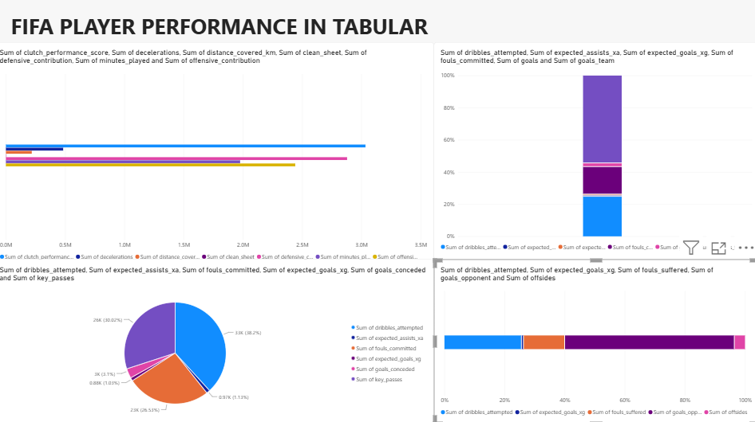
Figure: FIFA Player Performance – Tabular Visualization Dashboard

